# Photoshop logo 2 analysis

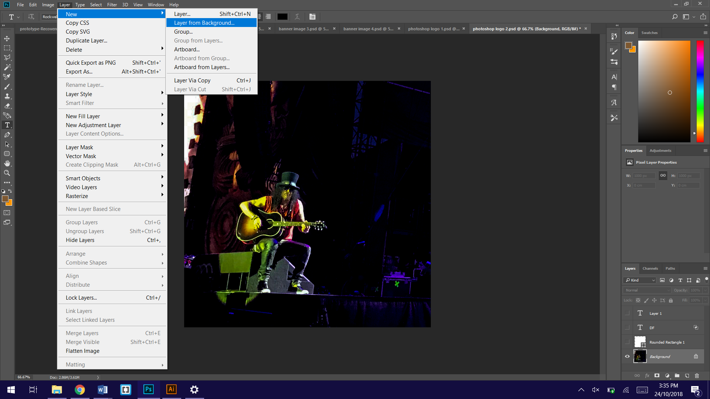

So that the effects used later on would work, after importing the image I needed to set it to the **background layer.** I did this by going to layer>new>layer from background. this sets the currently selected layer to be the background layer.

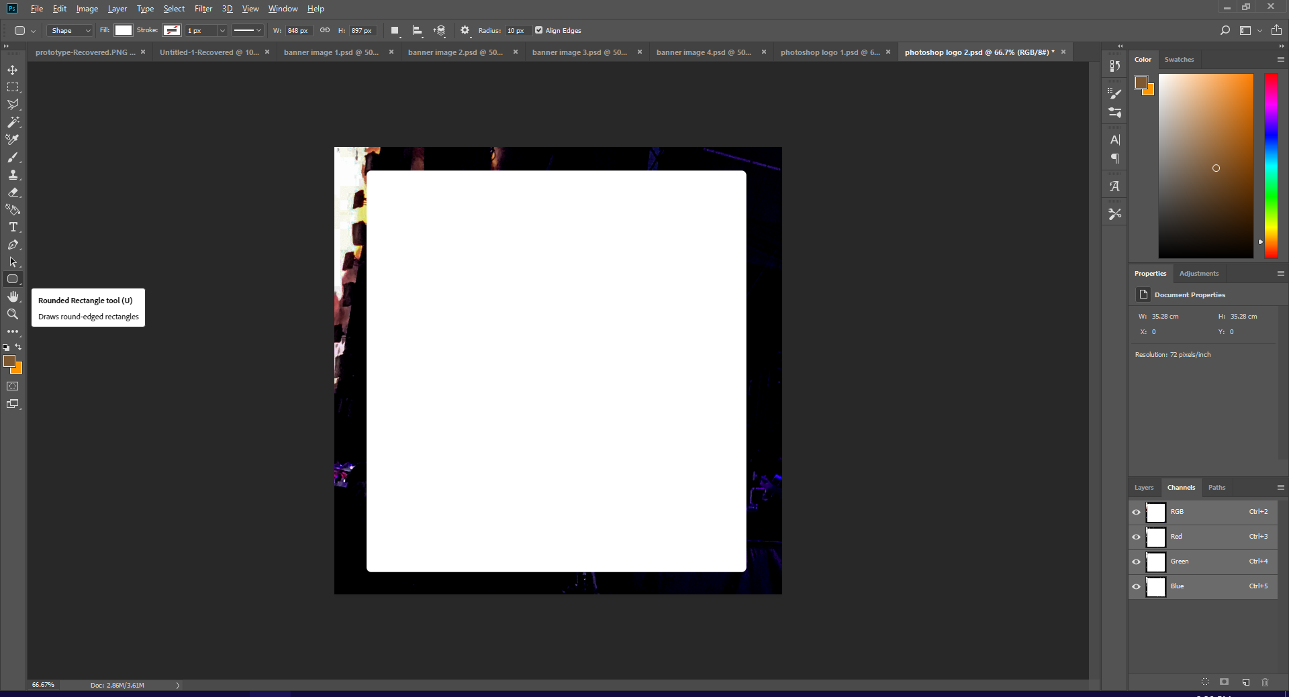

I then added a white rounded rectangle using the **shape tool**, which doesn’t quite fit the entire workspace. This allows some of the image behind to be shown.

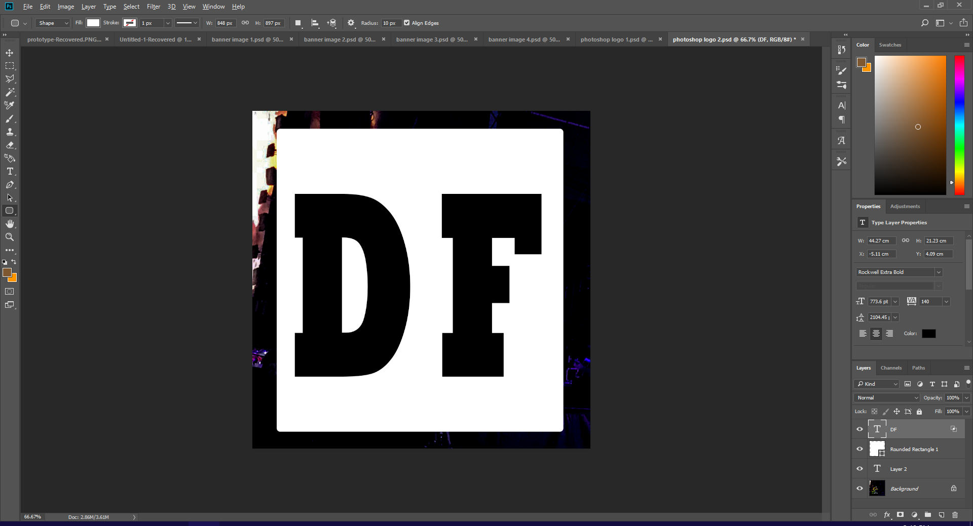

I then added the letters “DF” onto the rectangle using the **text tool**. These stand for Download Festival. I chose to only have the two letters on this logo because it would be distributed along side other media in a similar style, which would have the festivals full name and other details on it.

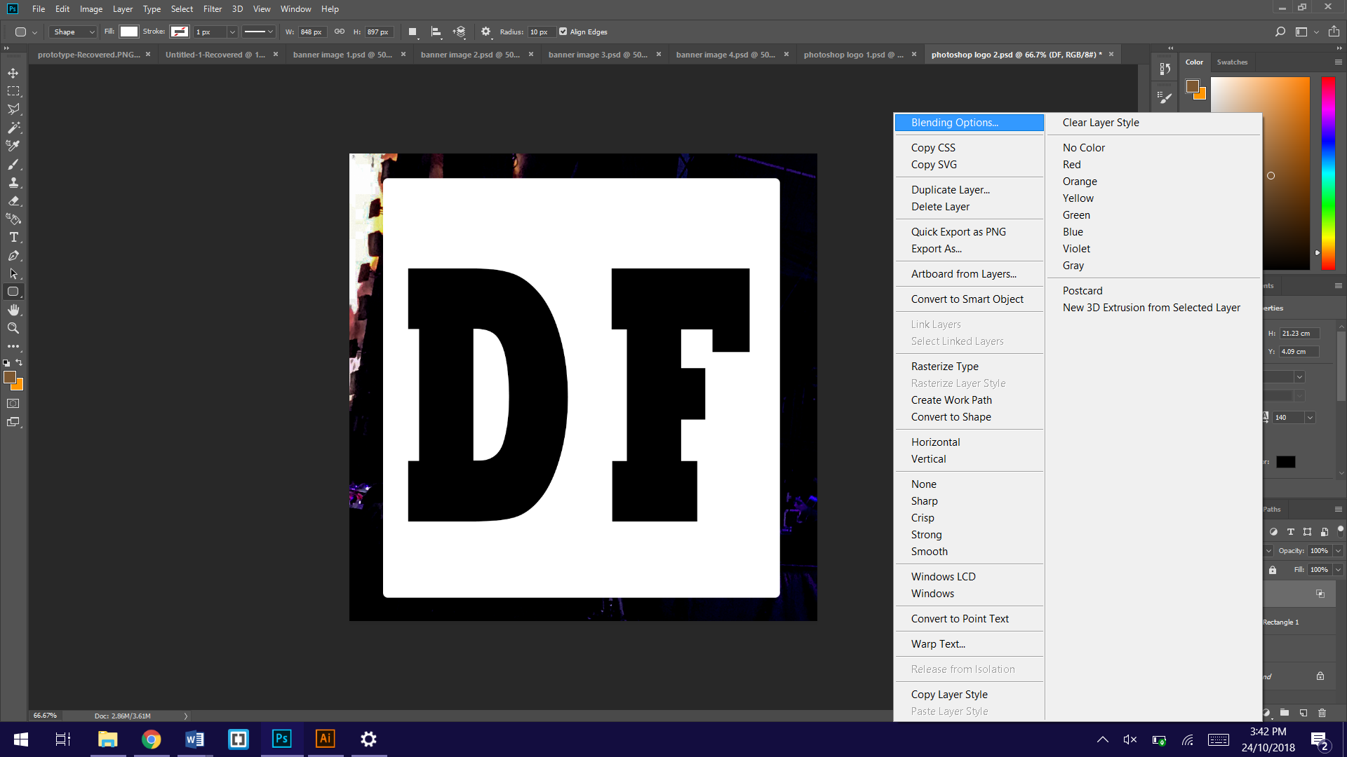

To make the letters knock out the white behind them revealing the image, I first went to **blending options**.

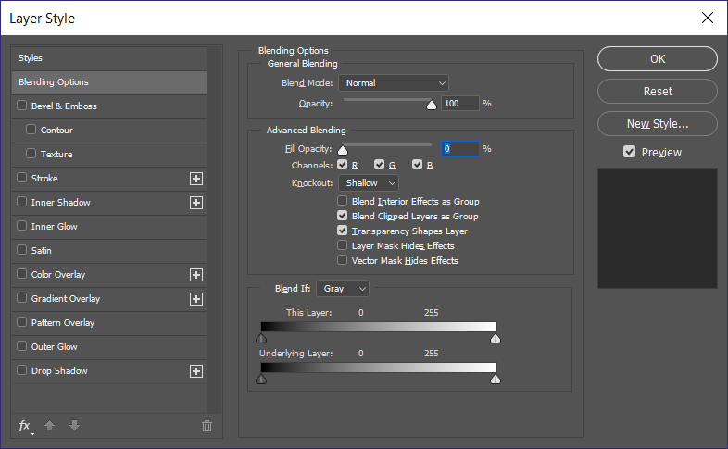

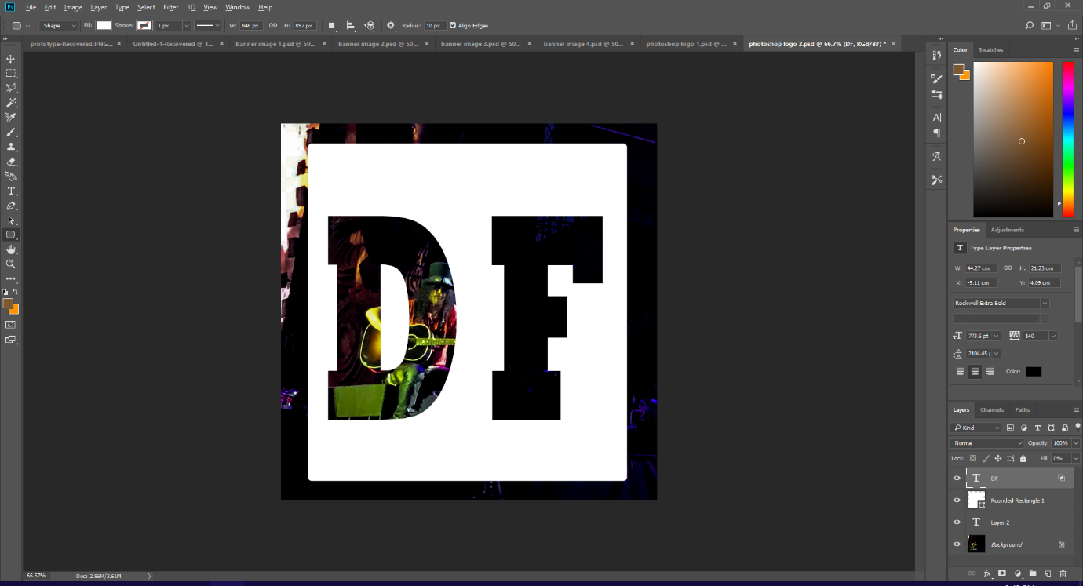Within blending options I **set knockout to shallow**, and set fill opacity to 0%.

This created the desired **knockout effect**, which showed the background image behind the rectangle through the lettering, making it look like the rectangle had the letters stamped or cut out.

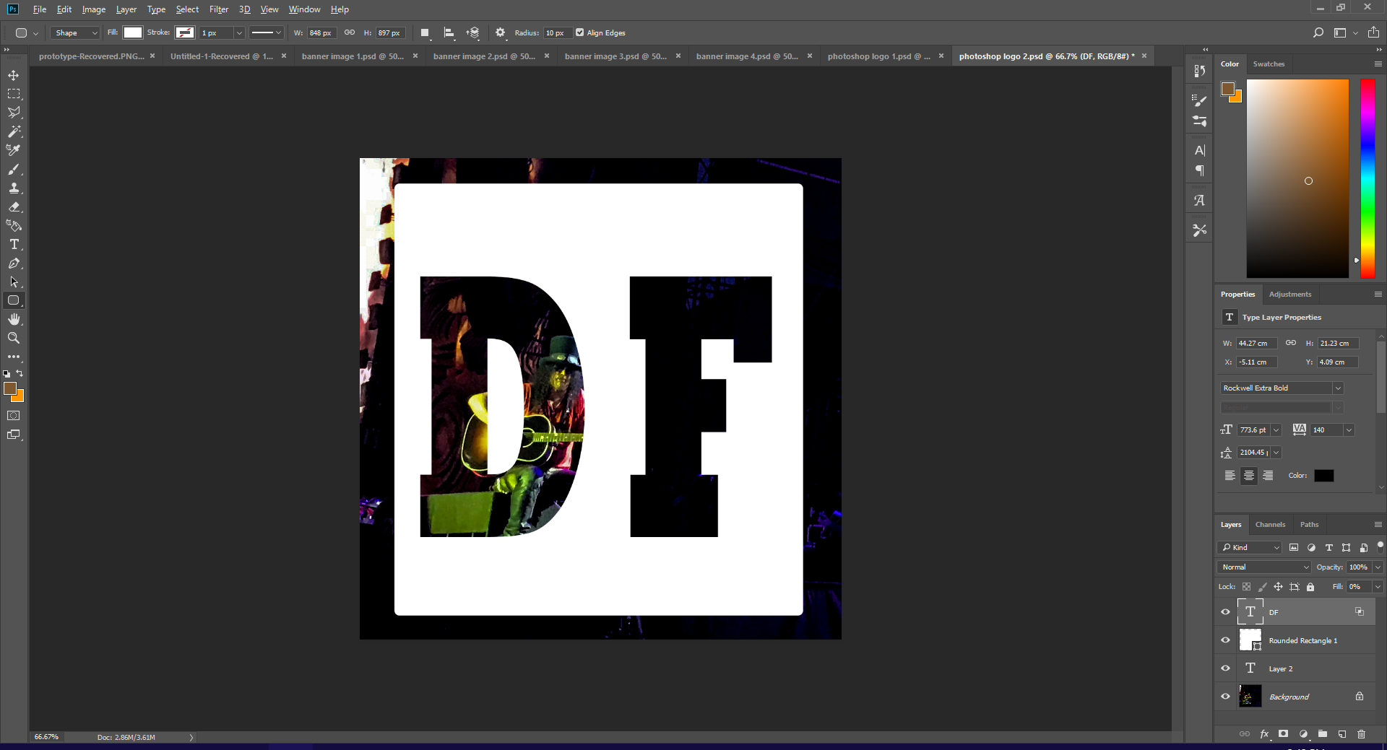

This logo is much better than the previous one (the gradient circle). This logo is a lot more modern looking and has more advanced techniques such as the knockout effect. However, it doesn’t target the target audience massively, as they would expect more messy looking graphics that appear to be hand drawn even if they aren’t, as rock and metal could be seen as messy or disorganised. This logo looks too clean and modern for this target audience. However, it does redeem itself somewhat my including slash in the background, who is one of rocks most famous guitarists. This makes the logo target the correct audience more than other logos as it directly links the logo to the music style played at the festival.